**LEARNING MANAGEMENT SYTEM**

|  |  |
| --- | --- |
| **CONTENT** | **PAGE NO** |
| **Abstract** |  |
| **1.INTRODUCTION** |  |
| 1.1 Motivation |  |
| 1.2 Problem Statement |  |
| 1.3 Objective of the Project |  |
| 1.4 Scope |  |
| 1.5 Project Introduction |  |
| **2.LTERATURE SURVEY** |  |
| 2.1 Related Work |  |
| **3. SYSTEM ANALYSIS** |  |
| 3.1 Existing System |  |
| 3.2 Disadvantages |  |
| 3.3 Proposed System |  |
| 3.4 Advantages |  |
| 3.5 work Flow of Proposed system |  |
| **4. REQUIREMENT ANALYSIS** |  |
| 4.1Function and non-functional requirements |  |
| 4.2 Hardware Requirements |  |
| 4.3 Software Requirements |  |
| 4.4 Architecture |  |
| **5. SYSTEM DESIGN** |  |
| 5.1 Introduction of Input design |  |
| 5.2 UML Diagram(class, use case, sequence, collaborative, deployment) |  |
| 5.3 Data Flow Diagram |  |
| **6. IMPLEMENTATION AND RESULTS** |  |
| 6.1 Modules |  |
| 6.2 Output Screens |  |
| 1. **ASP.NET ENVIRONMENT** |  |
| 7.1 Software Installation |  |
| 7.2 About .Net Language |  |
| 1. **SYSTEM STUDY AND TESTING** |  |
| 8.1 Feasibility study |  |
| 8.2 Types of test |  |
| **9. CONCLUSION** |  |
| **10. FUTURE ENHANCEMENT** |  |
| **11. REFERENCES** |  |

**ABSTRACT**

In the digital era, the proliferation of online education and the need for effective learning platforms have highlighted the importance of Learning Management Systems (LMS). This abstract presents a comprehensive overview of the design and development of a cutting-edge Learning Management System aimed at facilitating educational institutions and organizations in delivering high-quality and engaging online learning experiences. The proposed Learning Management System integrates a range of key features and functionalities to enhance the learning process. These include course management, content delivery, assessment and grading, learner engagement, collaboration tools, and performance tracking. The system employs a user-friendly interface, providing intuitive navigation and accessibility across various devices to accommodate diverse learning styles and preferences. The architecture of the Learning Management System comprises three primary components: the front-end user interface, the backend database, and the administrative panel. The front-end interface is designed to provide a visually appealing and interactive learning environment, offering seamless access to course materials, multimedia content, discussion forums, and real-time communication channels. The backend database serves as the central repository for storing and organizing educational resources, user profiles, and learner progress data. It employs robust security measures to protect sensitive information and ensures smooth data management and retrieval processes. The administrative panel grants instructors and administrators comprehensive control over course creation, enrollment management, user analytics, and system configuration.

**Keywords**: Teacher, Student, Course, payment, etc

.

1. **INTRODUCTION**

An e-commerce product management system serves as the backbone of any online business, enabling seamless organization, optimization, and monetization of products. It encompasses a range of processes, tools, and strategies designed to streamline product creation, marketing, sales, and customer satisfaction.

With an e-commerce product management system, businesses can efficiently handle inventory, categorize products, update pricing information, and manage orders. It allows businesses to curate appealing product descriptions, high-quality images, and detailed specifications, ensuring that customers have accurate and enticing information at their fingertips.

Beyond the core functions, a robust product management system also facilitates inventory tracking, demand forecasting, and automated reordering. This ensures that businesses can maintain optimal stock levels, minimize out-of-stock situations, and capitalize on emerging market trends, ultimately enhancing customer satisfaction and driving revenue growth.

Moreover, an effective product management system empowers businesses to analyze valuable data and gain insights into customer behavior, market trends, and sales performance. By leveraging this information, companies can make data-driven decisions, personalize their offerings, and tailor marketing strategies to target specific customer segments effectively.

In the dynamic realm of e-commerce, competition is fierce. A well-implemented product management system enables businesses to stay ahead by quickly adapting to market changes, launching new products, and optimizing their product portfolio based on customer preferences.

As technology continues to advance and consumer expectations evolve, an e-commerce product management system will become increasingly essential for businesses to thrive in the digital marketplace. By efficiently managing products, streamlining operations, and delivering exceptional customer experiences, organizations can build a strong online presence, increase sales, and unlock new opportunities for growth.

**1.1 Motivation:**

The motivation for adopting an LMS revolves around improving the learning experience, increasing efficiency, fostering engagement and collaboration, and achieving better learning outcomes. An LMS empowers learners and instructors with the necessary tools and resources to facilitate effective teaching and learning in a digital era.

**1.2 Problem Statement:**

Learning Management Systems. By developing innovative solutions that focus on standardization, learner engagement, comprehensive assessment, and inclusivity, LMS can truly empower educational institutions and organizations to deliver high-quality, personalized, and accessible online learning experiences that meet the needs of diverse learners in the digital age.

**1.3 Objective of the Project:**

The objective of the project –Learning management system application is as follows:

The objectives of a Learning Management System (LMS) can vary based on the specific needs and goals of educational institutions or organizations. However, some common objectives of an LMS include. These objectives collectively aim to optimize the learning experience, improve learner outcomes, and facilitate effective administration and management of online education and training programs.

**1.4 Scope:**

The scope of a Learning Management System (LMS) encompasses various aspects related to online education and training. Here are the key dimensions that fall within the scope of an LMS. the scope of a Learning Management System encompasses the management, delivery, assessment, engagement, tracking, administration, integration, and accessibility aspects of online education and training.

**1.5 Project Introduction:**

Introduction to the " **Learning management system**" Project:

A learning management system (LMS) is a powerful tool designed to facilitate the management, delivery, and tracking of educational content and training programs. It serves as a comprehensive platform that enables educators, trainers, and administrators to create, organize, distribute, and monitor learning materials and activities in a centralized digital environment.

An LMS is commonly used in various educational settings, including schools, universities, corporate training programs, and online learning platforms. It streamlines the learning process by providing a virtual space where instructors can create and share engaging content, communicate with learners, assess their progress, and foster interactive learning experiences.

The core functionalities of an LMS typically include:

Content Creation and Management: Users can create and upload a wide range of learning materials such as presentations, documents, videos, and quizzes. These resources can be organized into courses or modules for easy navigation.

Course Delivery: Learners can access the learning materials and activities at their own convenience, typically through a web-based interface or a mobile app. The LMS ensures that the content is available to the right users at the right time.

Communication and Collaboration: The LMS facilitates communication and collaboration between learners and instructors through discussion forums, messaging systems, and virtual classrooms. This promotes engagement, peer learning, and knowledge sharing.

Assessment and Feedback: Instructors can create assessments, quizzes, and assignments to evaluate learners' progress and understanding. The LMS automates grading processes, provides immediate feedback, and generates performance reports.

Progress Tracking and Reporting: Administrators and instructors can monitor learners' activities, track their progress, and generate detailed reports. This data allows for personalized instruction, identification of knowledge gaps, and assessment of the effectiveness of the learning programs.

Integration and Customization: LMSs often support integration with other software systems, such as student information systems or HR platforms. They also offer customization options to tailor the learning experience and interface to the specific needs of the organization or institution.

By harnessing the capabilities of a learning management system, educators and trainers can create engaging, flexible, and personalized learning experiences. Learners benefit from self-paced learning, access to rich multimedia content, interactive assessments, and opportunities for collaboration. Overall, an LMS serves as a powerful tool that empowers institutions and organizations to enhance the learning process, improve outcomes, and adapt to the evolving landscape of education and training.

Top of Form

1. **LITERATURE SURVEY**

**2.1 Related Work:**

**1."Learning management systems: An overview and comparative analysis" by Katherine Li and Richard Lalancette (2015)**

This paper provides an overview of LMS features, benefits, and challenges. It compares different LMS platforms and discusses their effectiveness in supporting teaching and learning.

**2. "Evaluating learning management system success" by Abdul Rahman Ahlan et al. (2014).**

This study presents a framework for evaluating the success of LMS implementation in higher education. It identifies key success factors and proposes a measurement model to assess LMS effectiveness.

**3."A systematic review of the literature on learning management system adoption: An overview of barriers and enablers" by Sahan Bulathwela et al. (2019).**

This review explores the barriers and enablers of LMS adoption in educational institutions. It identifies factors such as technical, organizational, and pedagogical aspects that influence successful implementation.

**4."Exploring students' acceptance of learning management systems: A case study in a Malaysian university" by Muhammad Awais Bin Asghar et al. (2017).**

This study investigates students' acceptance of an LMS and identifies factors influencing their intention to use the system. It highlights the importance of usability, perceived usefulness, and ease of use in determining LMS acceptance.

**5."A review of the literature on learning management system implementation: Benefits, challenges, and recommendations" by Rafael del Valle et al. (2018).**

This review synthesizes existing literature on LMS implementation in higher education. It discusses the benefits, challenges, and critical success factors of LMS adoption, and provides recommendations for effective implementation.

**6."A literature review on the effectiveness of learning management systems in higher education" by Shafika Isa et al. (2020).**

This literature review examines the effectiveness of LMS in supporting teaching and learning in higher education. It explores the impact of LMS on student outcomes, engagement, and satisfaction.

**3. SYSTEM ANALYSIS**

**3.1 Existing System**

Previously the learning management used to take physically. The process is as follows o Approaching libraries and study halls .Whenever student need to learn some courses , student should either buy some books or visit any central libraries. Here it will take time and manual process should be required.

**DISADVANTAGES**

o It is time consuming.

o It needs lot of human effort.

o More time for accessing.

o Possibility of proxies.

o Possibility for human errors.

.

**3.3 Proposed System**

The proposed system is a Learning management system designed to streamline and automate the process of bus course requests and getting courses. It aims to provide a user-friendly platform for student to buy courses online and operators to efficiently manage their providing online courses operations. The system will offer a range of features to enhance the buying courses for students .

**ADVANTAGES:**

o Easy interface for the administrator to work on.

o Easy access to students.

o Generating reports instantly.

o Less time consuming process.

o Less human errors and proxies.

**4. REQUIREMENT ANALYSIS**

**4.1 Functional and non-functional requirements**

Requirement’s analysis is very critical process that enables the success of a system or software project to be assessed. Requirements are generally split into two types: Functional and non-functional requirements.

**Functional Requirements**: These are the requirements that the end user specifically demands as basic facilities that the system should offer. All these functionalities need to be necessarily incorporated into the system as a part of the contract. These are represented or stated in the form of input to be given to the system, the operation performed and the output expected. They are basically the requirements stated by the user which one can see directly in the final product, unlike the non-functional requirements.

Examples of functional requirements:

1. Authentication of user whenever he/she logs into the system
2. System shutdown in case of a cyber-attack
3. A verification email is sent to user whenever he/she register for the first time on some software system.

**Non-functional requirements**: These are basically the quality constraints that the system must satisfy according to the project contract. The priority or extent to which these factors are implemented varies from one project to other. They are also called non-behavioral requirements.  
They basically deal with issues like:

* Portability
* Security
* Maintainability
* Reliability
* Scalability
* Performance
* Reusability
* Flexibility

Examples of non-functional requirements:

1. Emails should be sent with a latency of no greater than 12 hours from such an activity.
2. The processing of each request should be done within 10 seconds
3. The site should load in 3 seconds whenever of simultaneous users are > 10000
   1. **Hardware Requirements**

# Processor - I3/Intel Processor

Hard Disk - 160GB

Key Board - Standard Windows Keyboard

Mouse - Two or Three Button Mouse

Monitor - SVGA

RAM - 8GB

* 1. **Software Requirements:**

Operating System : Windows 7/8/10

Server side Script : React Js

Programming Language : ASP.Net

IDE/Workbench : VisualStudio

Server : MS Server

Database : MSSQL

* 1. **Architecture:**

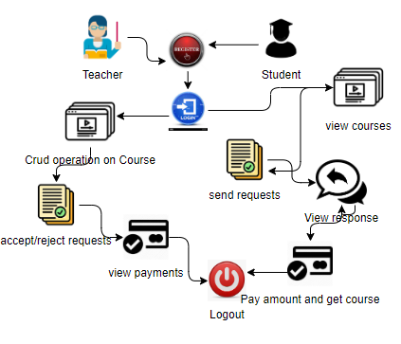

**5. SYSTEM DESIGN**

**5.1 Introduction of Input Design:**

In an information system, input is the raw data that is processed to produce output. During the input design, the developers must consider the input devices such as PC, MICR, OMR, etc.

Therefore, the quality of system input determines the quality of system output. Well-designed input forms and screens have following properties −

* It should serve specific purpose effectively such as storing, recording, and retrieving the information.
* It ensures proper completion with accuracy.
* It should be easy to fill and straightforward.
* It should focus on user’s attention, consistency, and simplicity.
* All these objectives are obtained using the knowledge of basic design principles regarding −
  + What are the inputs needed for the system?
  + How end users respond to different elements of forms and screens.

### **Objectives for Input Design:**

The objectives of input design are −

* To design data entry and input procedures
* To reduce input volume
* To design source documents for data capture or devise other data capture methods
* To design input data records, data entry screens, user interface screens, etc.
* To use validation checks and develop effective input controls.

**Output Design:**

The design of output is the most important task of any system. During output design, developers identify the type of outputs needed, and consider the necessary output controls and prototype report layouts.

### Objectives of Output Design:

The objectives of input design are:

* To develop output design that serves the intended purpose and eliminates the production of unwanted output.
* To develop the output design that meets the end user’s requirements.
* To deliver the appropriate quantity of output.
* To form the output in appropriate format and direct it to the right person.
* To make the output available on time for making good decisions.

**5.2 UML Diagrams:**

**5.2.1 Use Case Diagram:**

A use case diagram in the Unified Modeling Language (UML) is a type of behavioral diagram defined by and created from a Use-case analysis. Its purpose is to present a graphical overview of the functionality provided by a system in terms of actors, their goals (represented as use cases), and any dependencies between those use cases. The main purpose of a use case diagram is to show what system functions are performed for which actor. Roles of the actors in the system can be depicted.

**5.2.2 Class Diagram:**

In software engineering, a class diagram in the Unified Modelling Language (UML) is a type of static structure diagram that describes the structure of a system by showing the system's classes, their attributes, operations (or methods), and the relationships among the classes. It explains which class contains information.

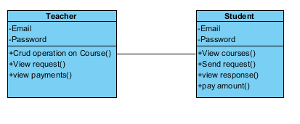

**5.2.3 Sequence Diagram:**

A sequence diagram in Unified Modelling Language (UML) is a kind of interaction diagram that shows how processes operate with one another and in what order. It is a construct of a Message Sequence Chart. Sequence diagrams are sometimes called event diagrams, event scenarios, and timing diagrams.

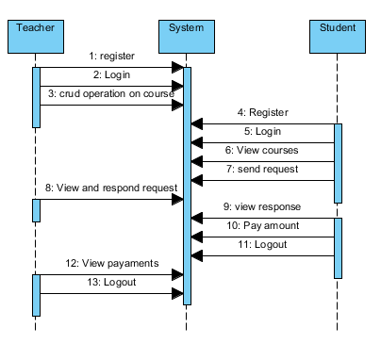

**5.2.4 Collaboration Diagram:**

In collaboration diagram the method call sequence is indicated by some numbering technique as shown below. The number indicates how the methods are called one after another. We have taken the same order management system to describe the collaboration diagram. The method calls are similar to that of a sequence diagram. But the difference is that the sequence diagram does not describe the object organization whereas the collaboration diagram shows the object organization.

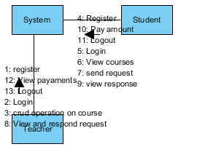

**5.2.5 Deployment Diagram**

Deployment diagram represents the deployment view of a system. It is related to the component diagram. Because the components are deployed using the deployment diagrams. A deployment diagram consists of nodes. Nodes are nothing but physical hardware’s used to deploy the application.

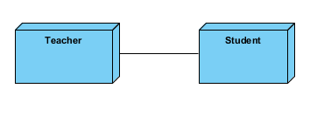

**5.2.6 Activity Diagram:**

Activity diagrams are graphical representations of workflows of stepwise activities and actions with support for choice, iteration and concurrency. In the Unified Modelling Language, activity diagrams can be used to describe the business and operational step-by-step workflows of components in a system. An activity diagram shows the overall flow of control.

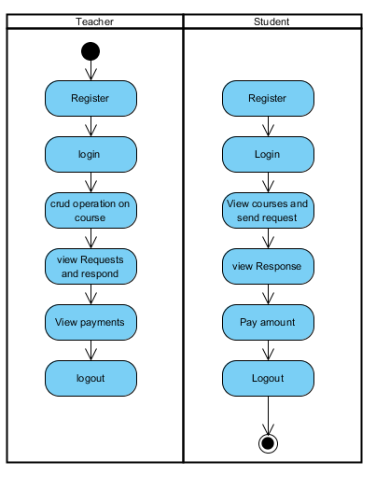

**5.2.7 Component Diagram**:

A component diagram, also known as a UML component diagram, describes the organization and wiring of the physical **c**omponents in a system. Component diagrams are often drawn to help model implementation details and double-check that every aspect of the system's required functions is covered by planned development.

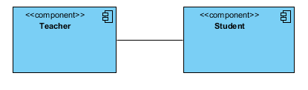

**5.2.8 ER Diagram:**

An Entity–relationship model (ER model) describes the structure of a database with the help of a diagram, which is known as Entity Relationship Diagram (ER Diagram). An ER model is a design or blueprint of a database that can later be implemented as a database. The main components of E-R model are: entity set and relationship set.

An ER diagram shows the relationship among entity sets. An entity set is a group of similar entities and these entities can have attributes. In terms of DBMS, an entity is a table or attribute of a table in database, so by showing relationship among tables and their attributes, ER diagram shows the complete logical structure of a database. Let’s have a look at a simple ER diagram to understand this concept.

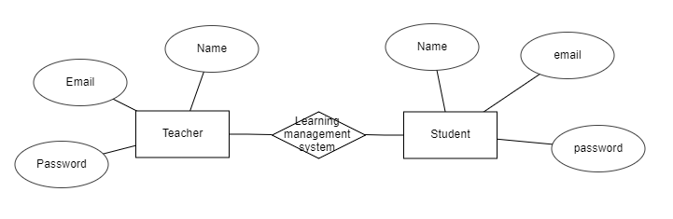

**5.3 DFD Diagram:**

A Data Flow Diagram (DFD) is a traditional way to visualize the information flows within a system. A neat and clear DFD can depict a good amount of the system requirements graphically. It can be manual, automated, or a combination of both. It shows how information enters and leaves the system, what changes the information and where information is stored. The purpose of a DFD is to show the scope and boundaries of a system as a whole. It may be used as a communications tool between a systems analyst and any person who plays a part in the system that acts as the starting point for redesigning a system.

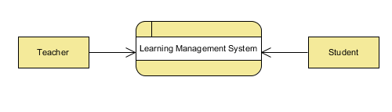

**Level 1 Diagram:**

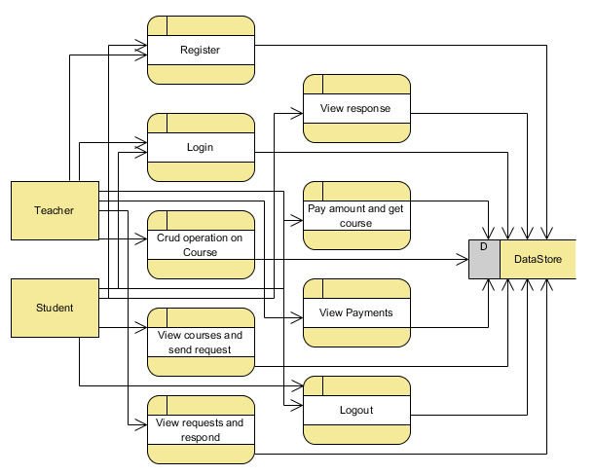

**Level 2 Diagram:**

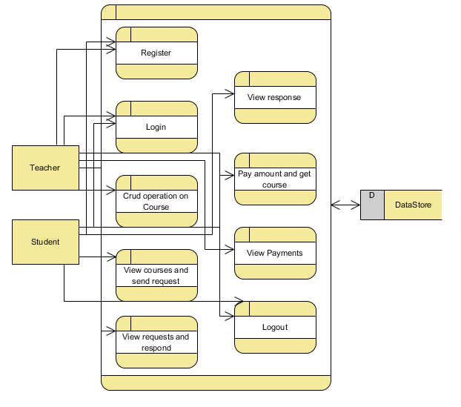

**IMPLEMENTATION AND RESULTS**

**6.1 Modules:**

In this application involved Two characters to implement this process they are Teacher, Student.

**Teacher :** Student is person to upload all details.

Operation-**Register:** Teacher will register into the application by entering the own details like (username and password , etc).

**Login:** Student will login into the application by entering the default credentials like (username and password).

Operation-**Add /update/delete:** Teacher can manage course details.

Operation- **View Course requests :** Teacher can manage course request details.

Operation- **View Payment details :** Teacher can manage view payment from students.

Operation- **Enable course details :** Teacher can manage view course details to students .

**Student :** Student is person to upload all details.

Operation-**Register:** Student will register into the application by entering the own details like (username and password ,etc).

Operation-**Login:** Student will login into the application by entering the valid details like (username and password).

Operation- **View Course details :** Read all the details about courses

Operation- **Send Request :** Student can send request for buy the course

Operation- **View response :** Student can send view response from teacher.

Operation- **Payment :** Student can pay amount for accepted course .

Operation-**Get Courses :** Student can get course after pay the amount.

**6.2 Results:**

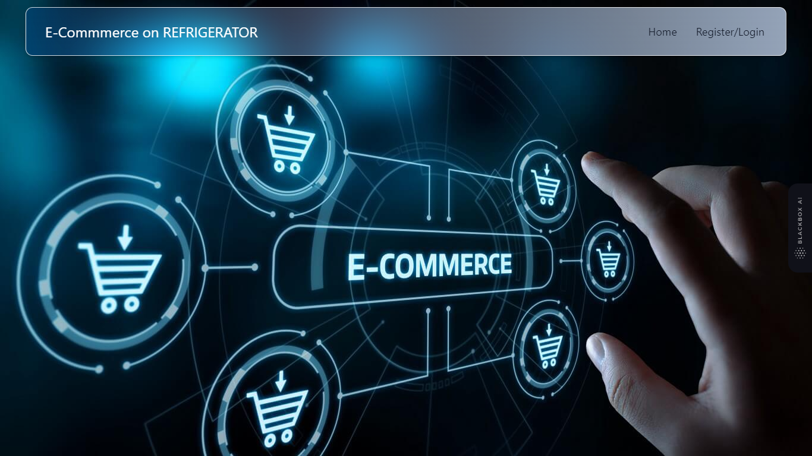

**Home Page :** This is the home page of our project.

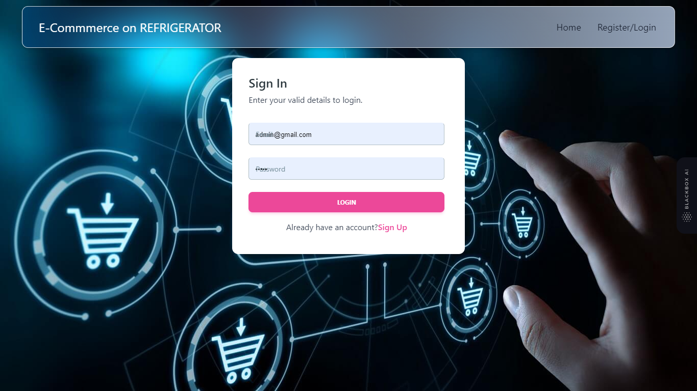

**Login :** Here both Admin and User login page.

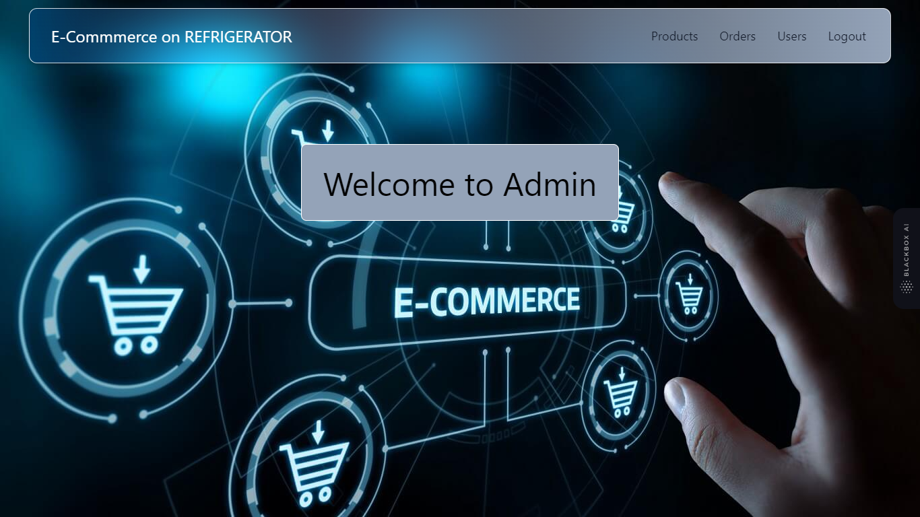

**Admin Home :** This is the admin Home page.

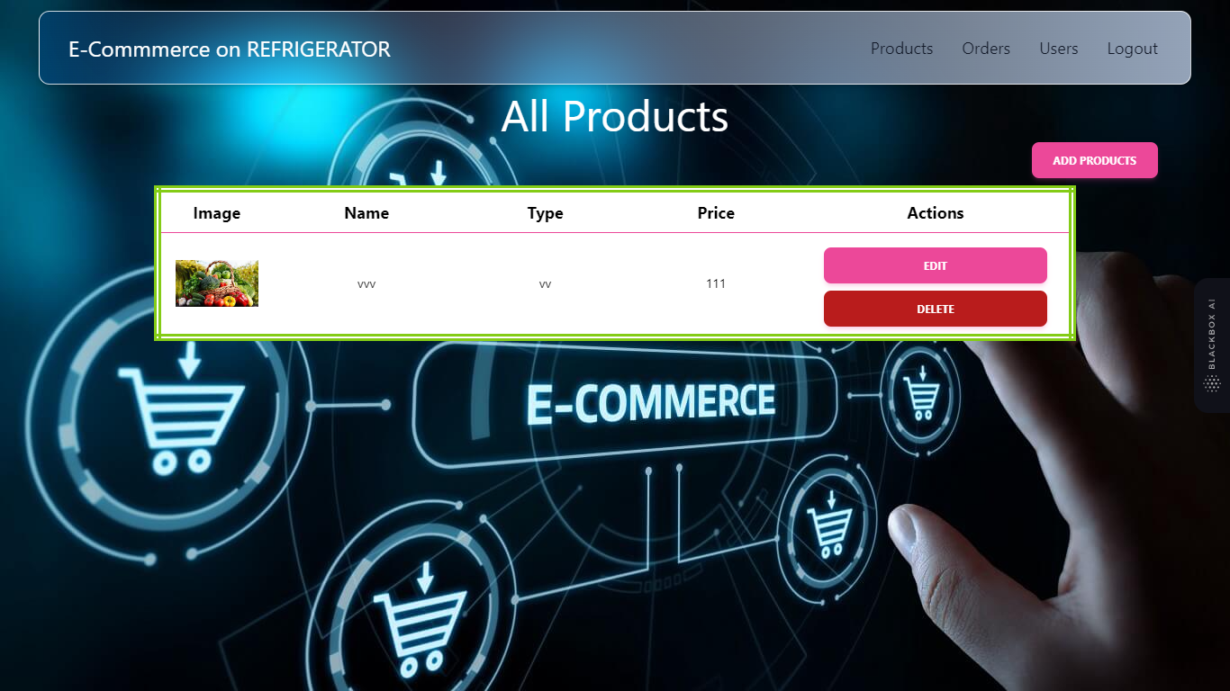

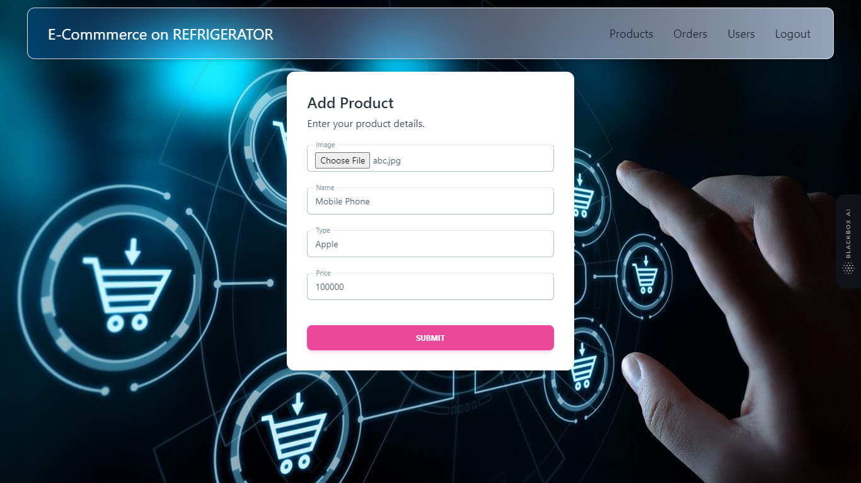

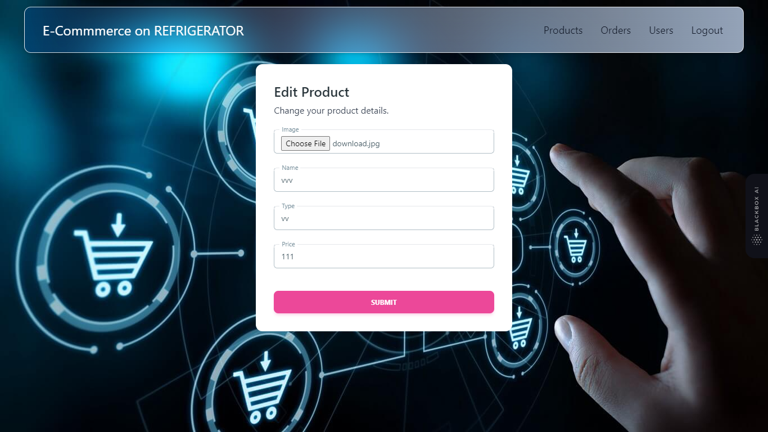

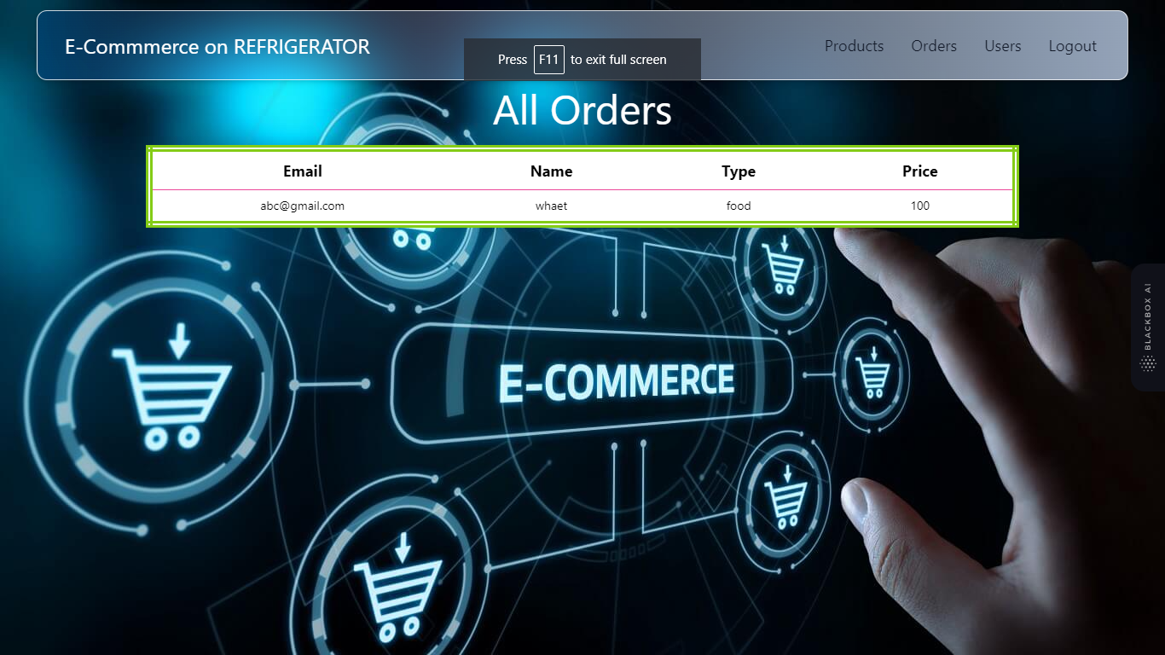

**View orders:** Here admin can view all orders

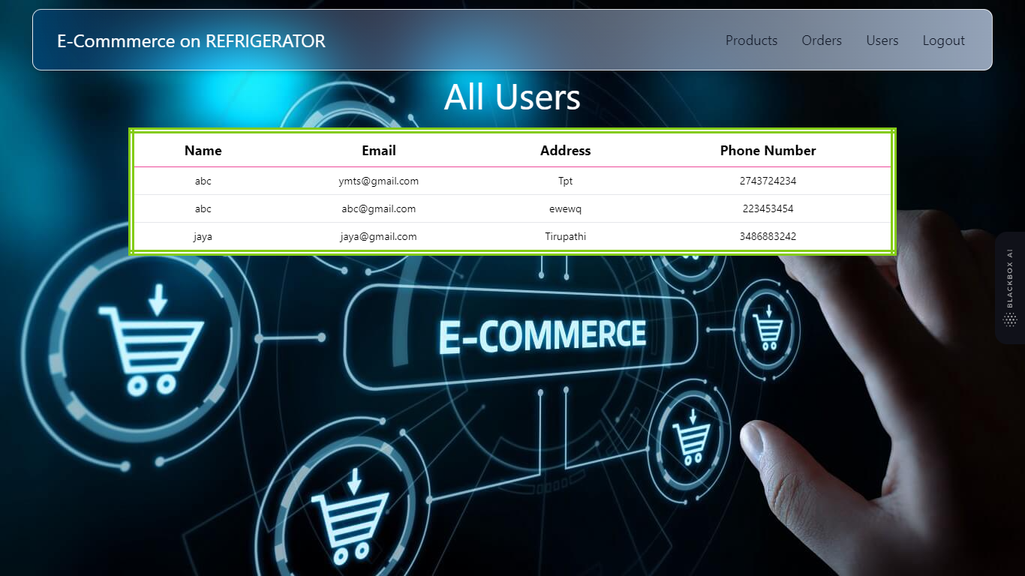

**View users:**  Here admin can view all users

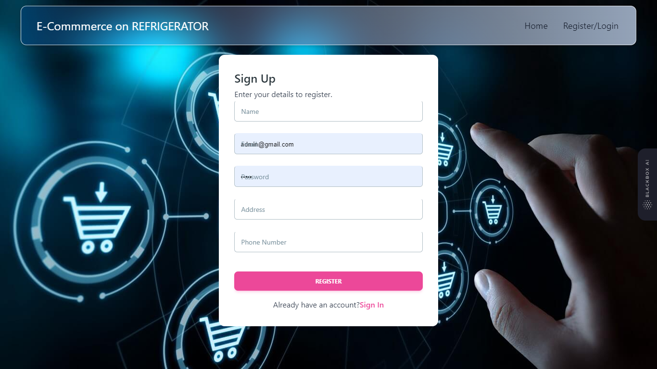

**User Register:** Here user can register with his own details.

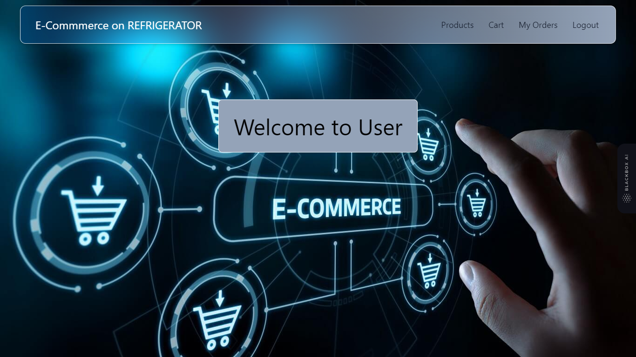

**User Home :** This is the user Home page.

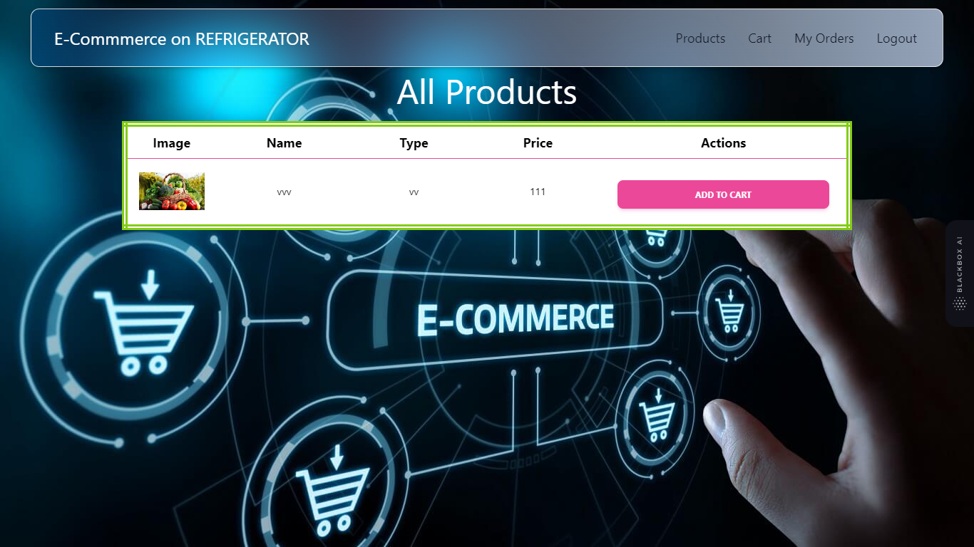

**View Products :**  Here user can view all the products

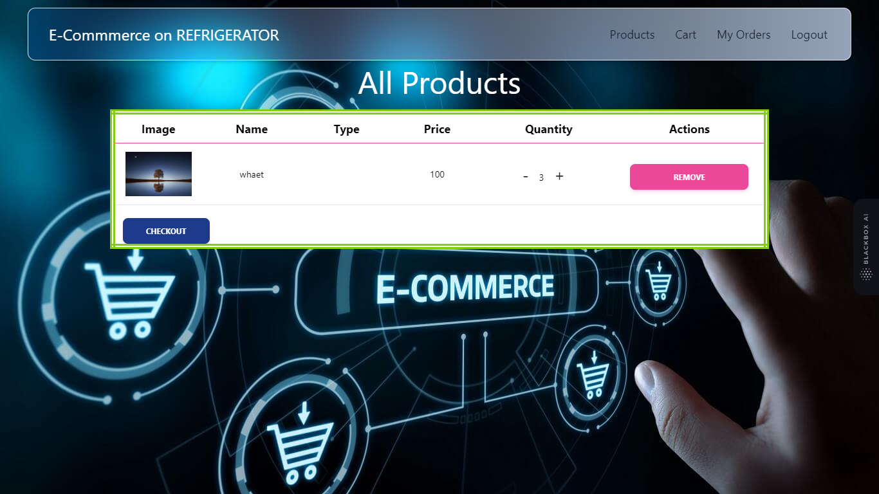

**View cart:** This is cart of user and he can checkout the all the products in the cart.

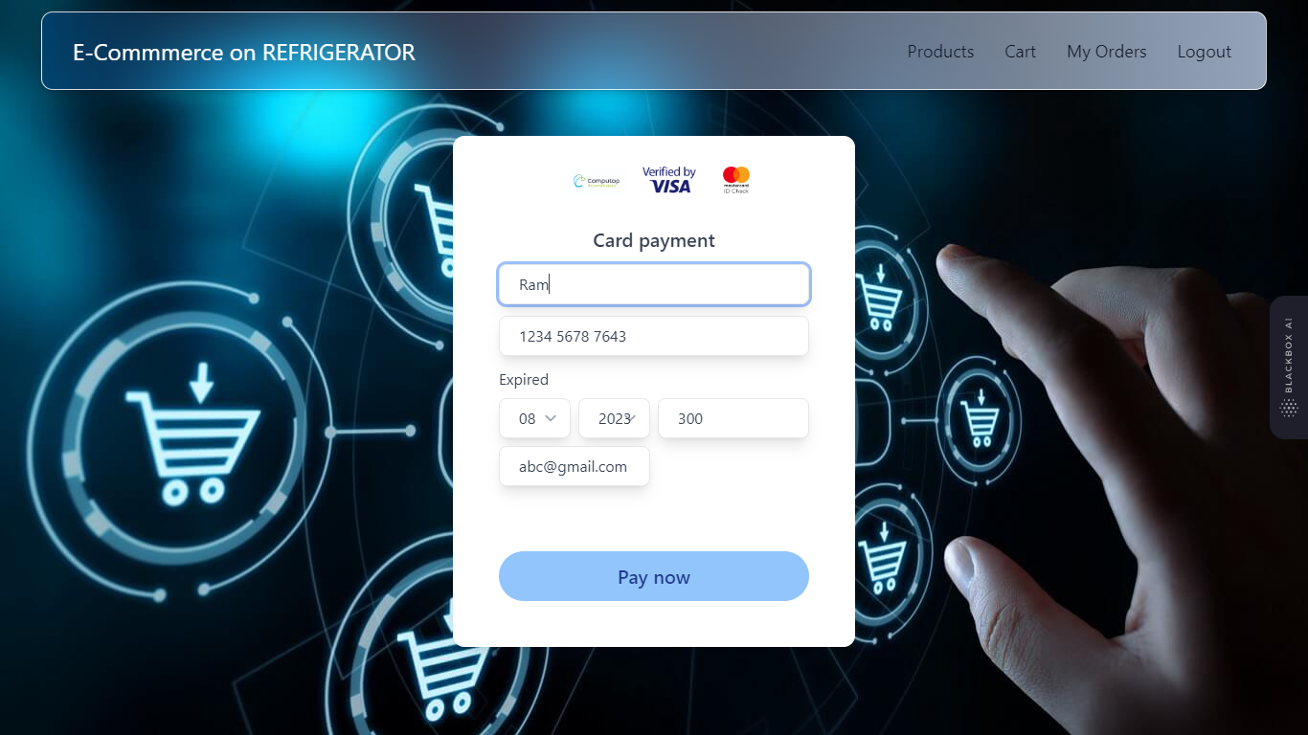

**Payment Page:** Here user can pay amount for cart items

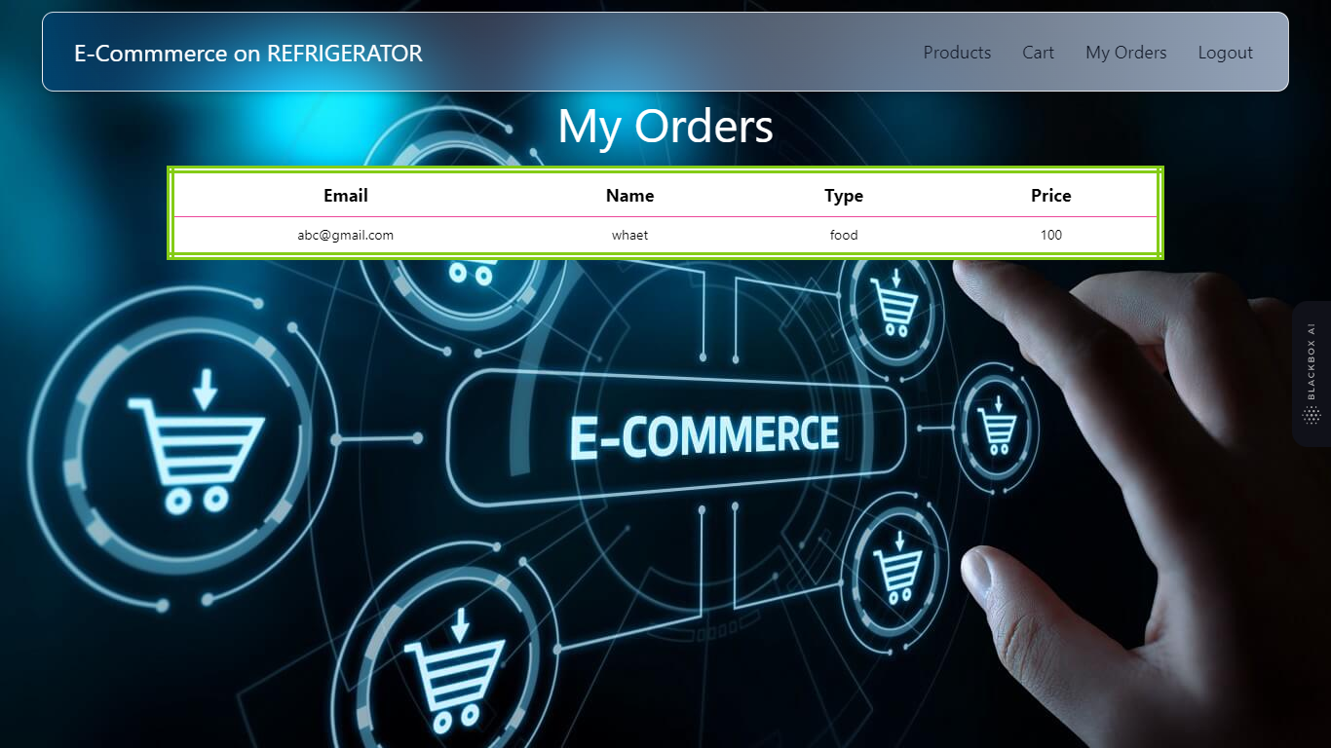

**View Orders :** Here user can view his orders.

**7. NODE ENVIRONMENT**

**Installing visual studio code**

Steps to installing visual studio code:

Step 1: Head over to the website <https://code.visualstudio.com/download>

Step2:choose the option as per your choice.

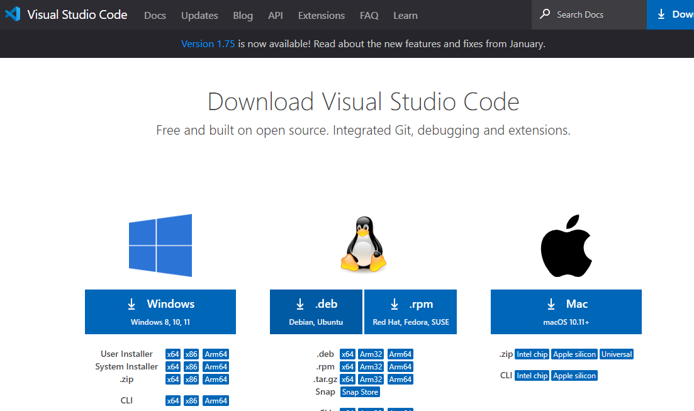

Step 3: Once download completed,open it and your screen will appear like this

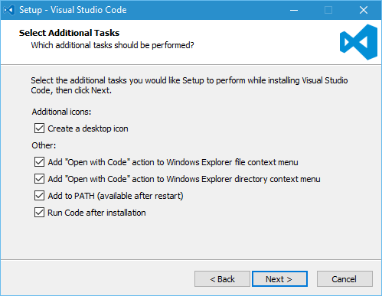

Step 4: click next until you saw the below page

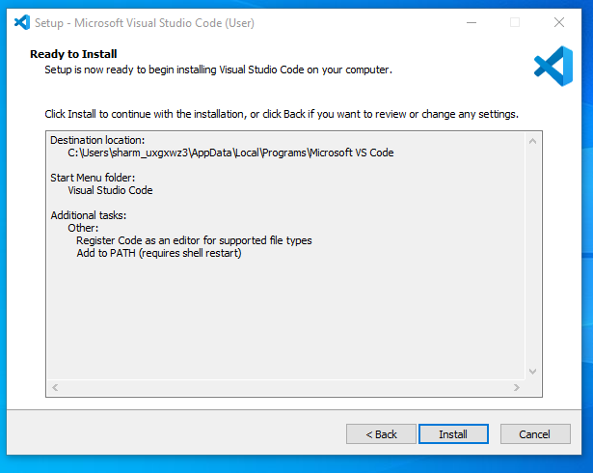

Step 4: After installation your screen will appear like this ,click finish and continue.

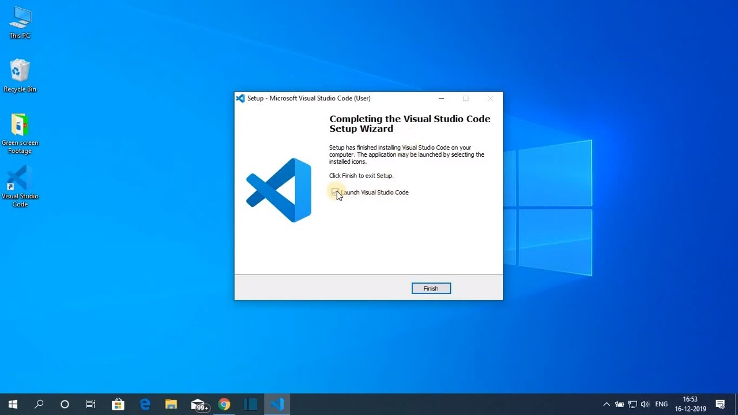

**Installing Node**

You have to follow the following steps to install the Node.js on your Windows :

**Step-1:** Downloading the Node.js ‘.msi’ installer.

The first step to install Node.js on windows is to download the installer. Visit the official Node.js website i.e) <https://nodejs.org/en/download/>and download the .msi file according to your system environment (32-bit & 64-bit). An MSI installer will be downloaded on your system.

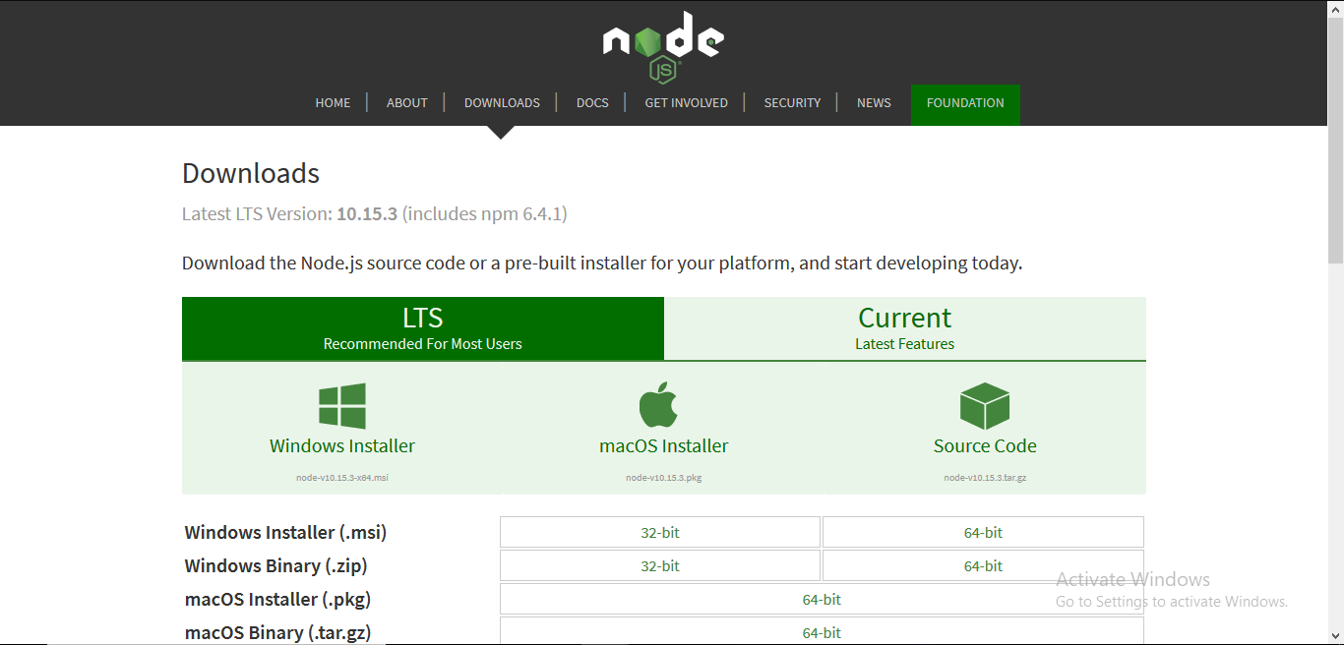 **Step-2:** Running the Node.js installer.

Now you need to install the node.js installer on your PC. You need to follow the following steps for the Node.js to be installed:-

* Double click on the .msi installer.

***The Node.js Setup wizard will open.***

* Welcome To Node.js Setup Wizard.

***Select “Next”***

* 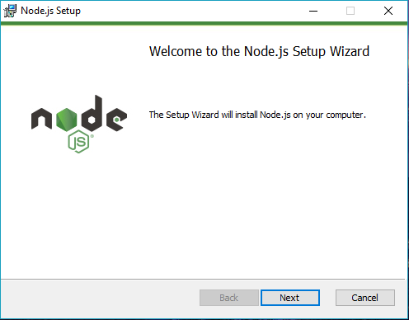
* After clicking “Next”, End-User License Agreement (EULA) will open.

***Check “I accept the terms in the License Agreement”***

***Select “Next”***

* 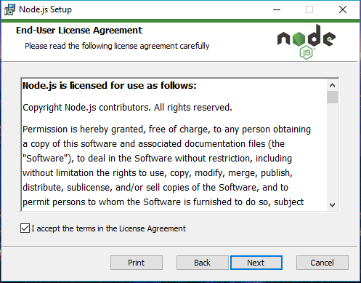
* Destination Folder

***Set the Destination Folder where you want to install Node.js & Select “Next”***

* 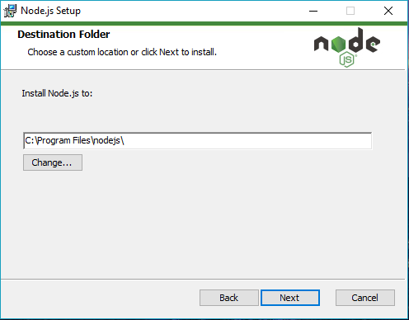
* Custom Setup

***Select “Next”***

* 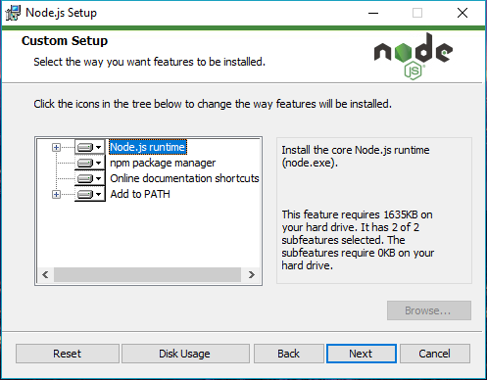
* Ready to Install Node.js.

The installer may prompt you to “install tools for native modules”.

For more information on whether you need this, see [here](https://github.com/nodejs/help/issues/3761).

***Select “Install”***

* 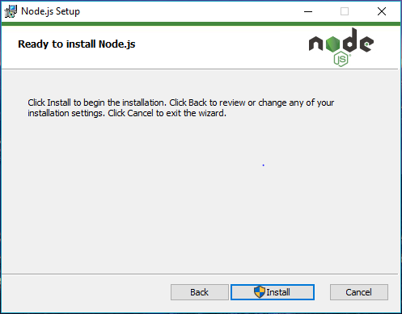
* Installing Node.js.

Do not close or cancel the installer until the install is complete

* Complete the Node.js Setup Wizard.

***Click “Finish”***

* 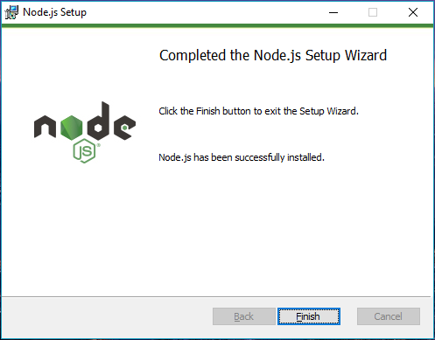

**Step 3: Verify that Node.js was properly installed or not.**

To check that node.js was completely installed on your system or not, you can run the following command in your command prompt or Windows Powershell and test it:-

***C:\Users\Admin> node -v***

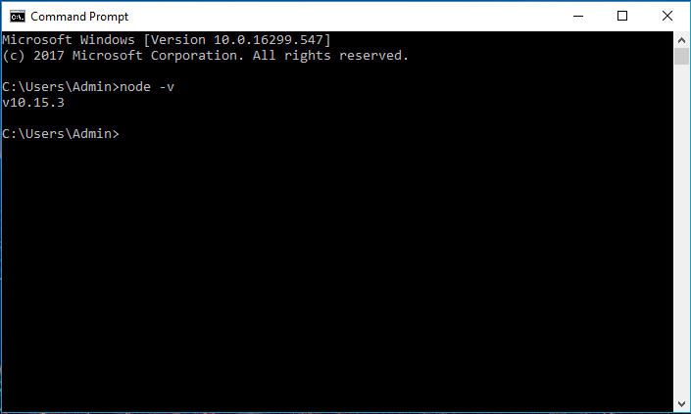

If node.js was completely installed on your system, the command prompt will print the version of the node.js installed.

## **Download SQL Server 2019 Developer Edition**

First, let’s download SQL Server installation media from the official website.

**Step 1**

Download installation media from this [link](https://www.microsoft.com/en-us/sql-server/sql-server-downloads).

**Step 2**

Run the downloaded file and you will see the below screen. Now select the third option – **Download Media**.

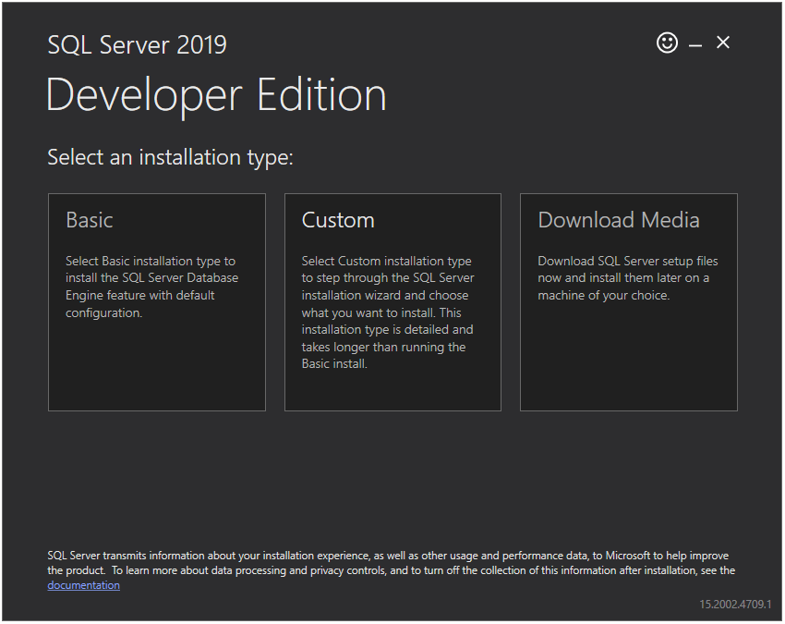

**Step 3**

Now you will see the below screen. Please select the language you prefer and select the **ISO** radio button to download the ISO file. In addition, select the download location of your choice. I will go with the default location. Now press the **Download** button.

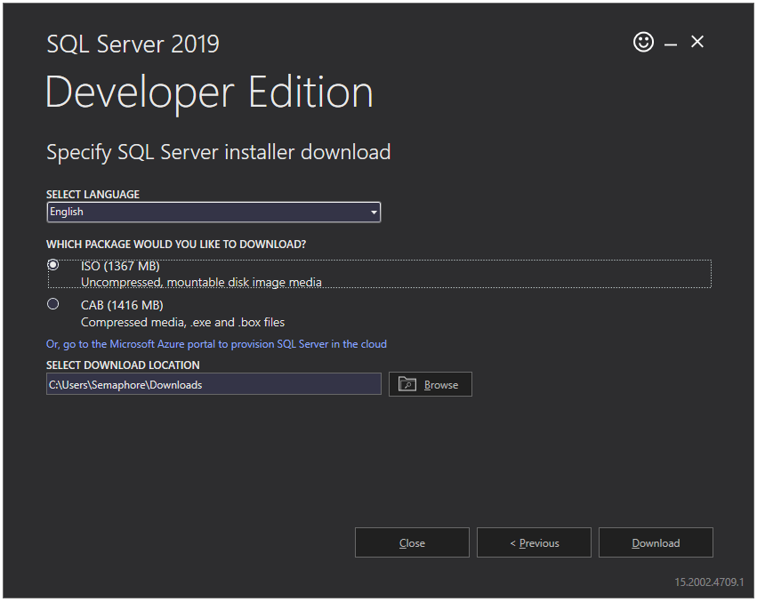

**Step 4**

Now it will start downloading SQL Server installation media. It will take some time based on your internet connection speed.

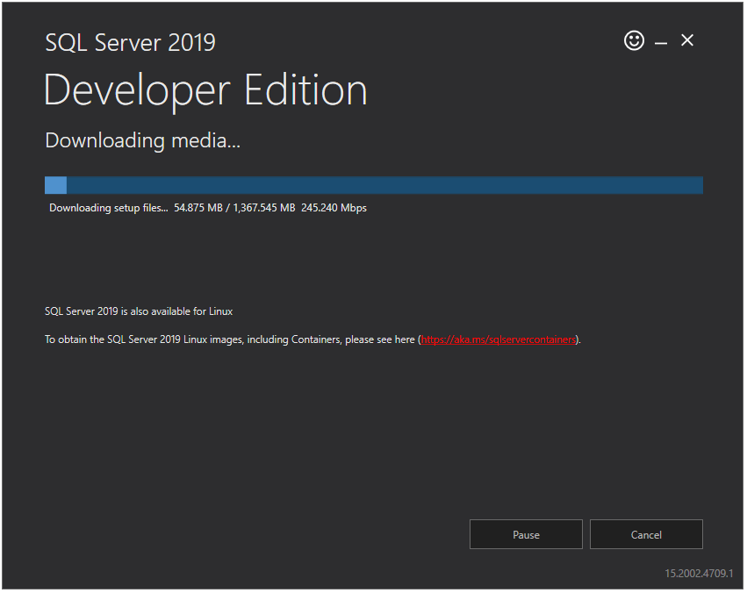

**Step 5**

After successful download of installation media, you will see the below screen. Click the **Close** button.

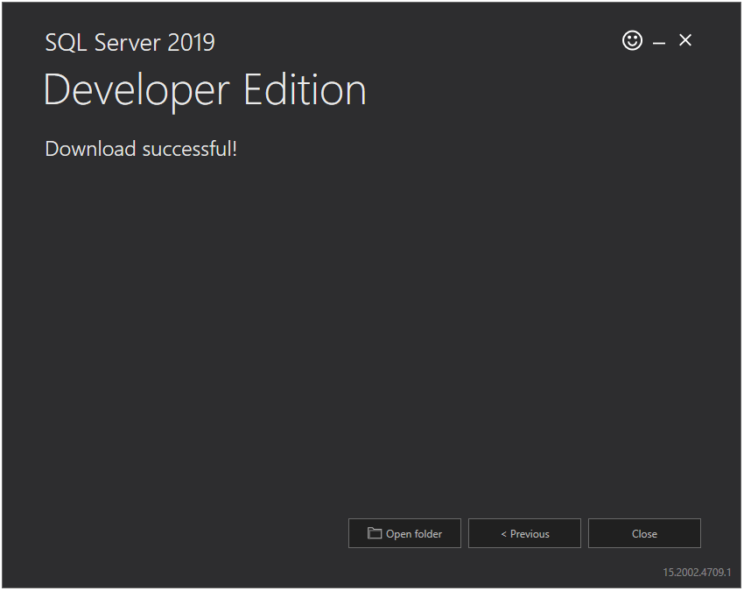

## **Install SQL Server 2019 Developer Edition**

Now that we have installation media, we can start the installation of the SQL Server. Let’s see how to install SQL Server step by step.

**Step 1**

Run install media file (ISO file) downloaded in above section by double-clicking on it. It will extract/mount all the contents in a new temporary drive.

  
Image 1 - ISO file

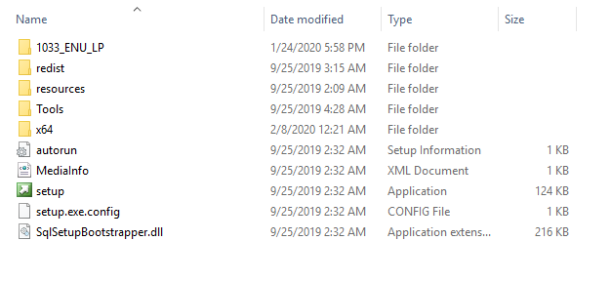  
Image 2 – Extracted contents

**Step 2**

Once extraction is completed, double click on the **setup.exe** file and you will see the below screen. Click on the **Installation** option in the left panel and then click on **New SQL Server stand-alone installation or add features to an existing installation** option from the right panel.

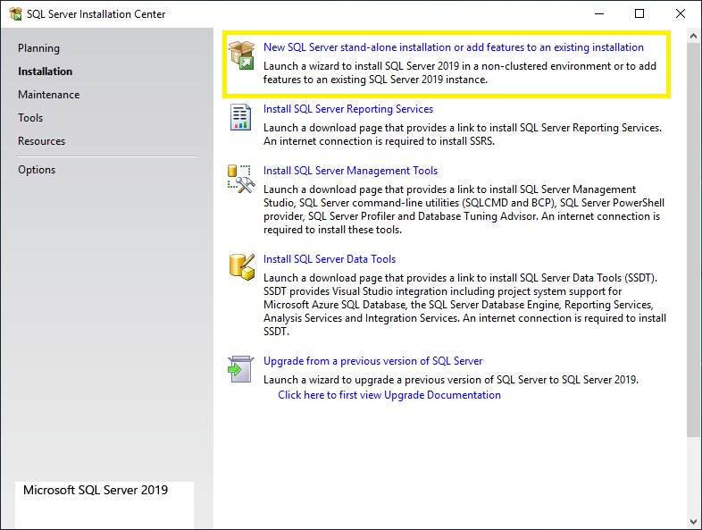

**Step 3**

Now you will see the **Product Key** window. Select the **Developer** option from the dropdown and click on the **Next** button.

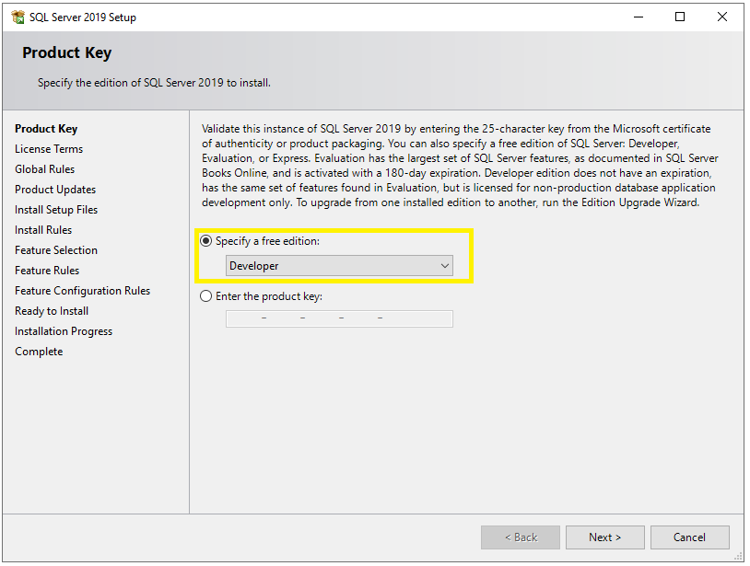

**Step 4**

Now you will see the **License Terms** window. Just select the checkbox and click on the **Next** button.

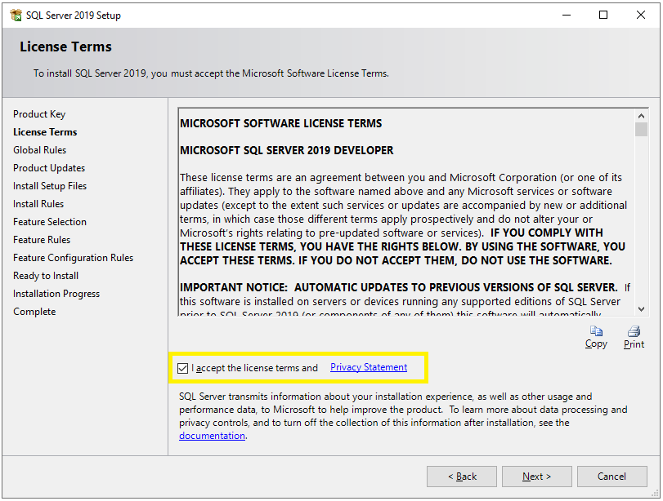

**Step 5**

Now you will see the **Microsoft Update** window. It is not compulsory to check for the latest updates but it is recommended. So, select the checkbox and click the **Next** button.

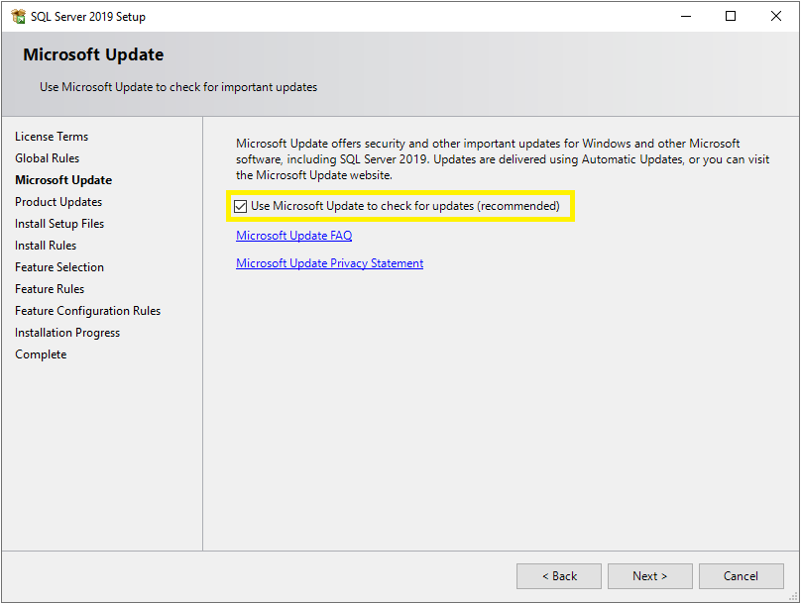

**Step 6**

Now it will check for updates and install them if any.

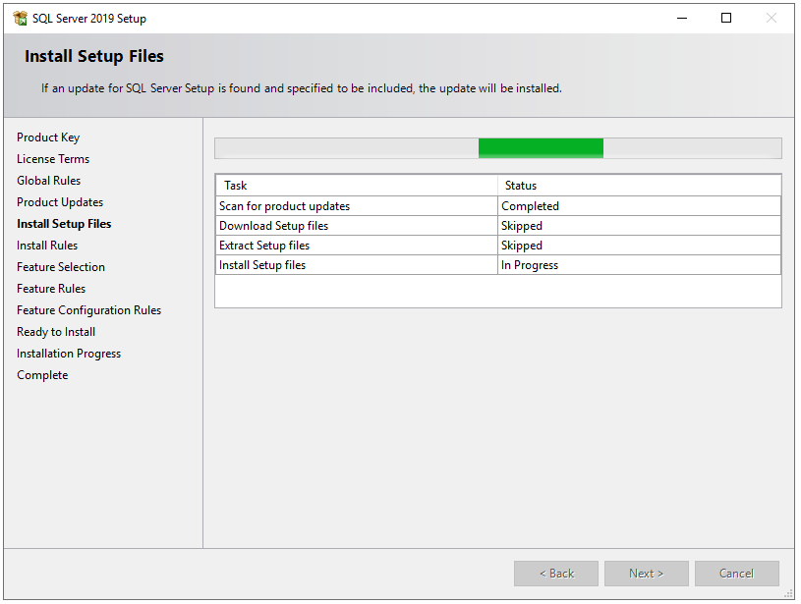

**Step 7**

After that, it will check some rules or prerequisites for the installation of SQL Server. Once all the rules passed, click on the **Next** button. Sometimes you may face an error at this stage. You can find some known errors at the end of this article.

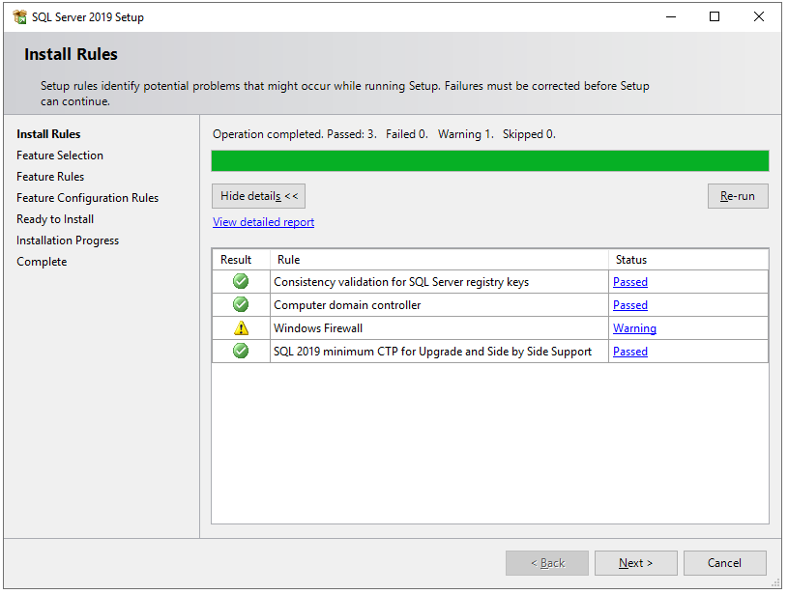

**Step 8**

On the **Feature Selection** window, select features as shown in the below screenshot. You can also change the location for SQL Server instance installation but I will go with the default location. After feature selection please click the **Next** button.

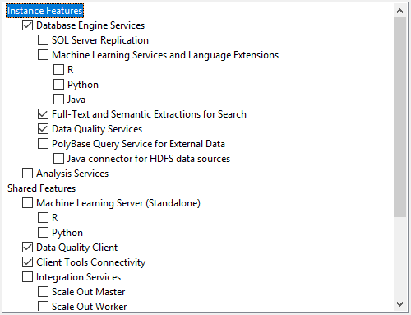 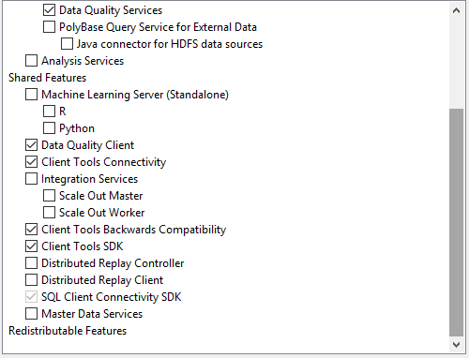  
Image 1 – Features selection Image 2 - Features selection

**Step 9**

It will check some feature rules/prerequisites and then you will see the **Instance Configuration** screen. Here you can choose between **Default Instance**and **Named Instance**. Here I will go with **Named Instance**.

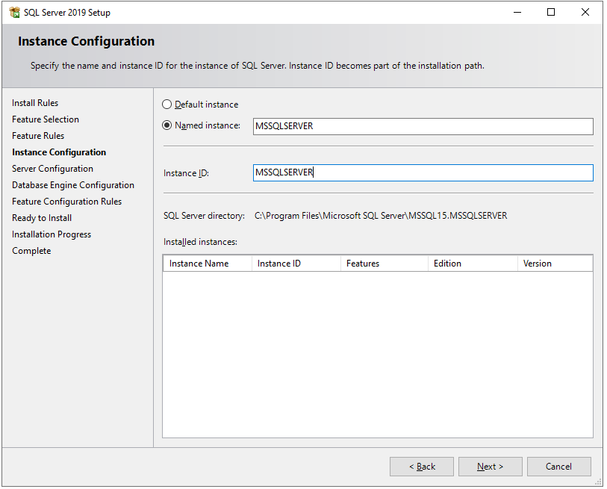

**Note**

**Default Instance**

When SQL Server is installed in the default instance, it does not require a client to specify the name of the instance to make a connection. The client only has to know the server name. For example, **HARDIK-PC.**

**Named Instance**

A named instance is identified by the network name of the computer plus the instance you specify during the installation. The client must specify both the server name and the instance name when connecting. For example, **HARDIK-PC/MSSQLSERVER.**

**Step 10**

Next, you will see the **Server Configuration** window. In **Service Accounts** tab, select **Automatic** in **Startup Type** for **SQL Server Agent, SQL Server Database Engine,** and **SQL Server Browser** services.

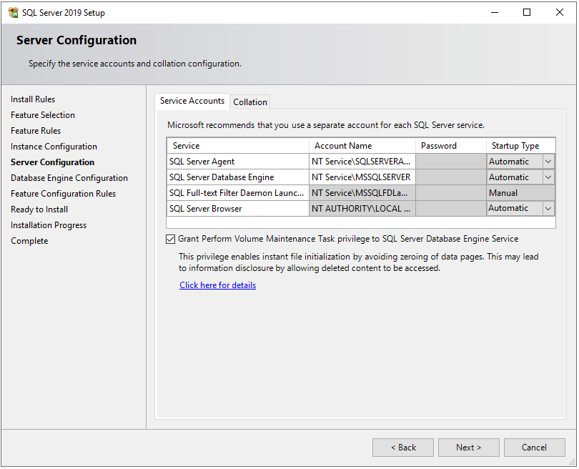

In the **Collation** tab, select collation as per your preference.

“Collations in SQL Server provide sorting rules, case, and accent sensitivity properties for your data. Collations that are used with character data types, such as ***char*** and ***varchar***, dictate the code page and corresponding characters that can be represented for that data type.” – Microsoft.

Ref: <https://docs.microsoft.com/en-us/sql/relational-databases/collations/collation-and-unicode-support?view=sql-server-ver15>

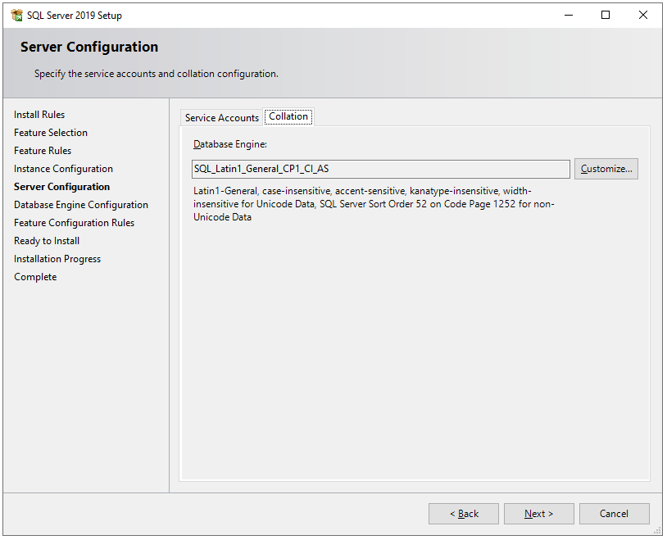

**Step 11**

Next, you will see the **Database Engine Configuration** window. In the **Server Configuration** tab, choose **Mixed Mode** in the authentication mode section and enter a strong password. In **Specify SQL Server administrators** section, your current windows user should already be added automatically. If not, click on **Add Current User** button.

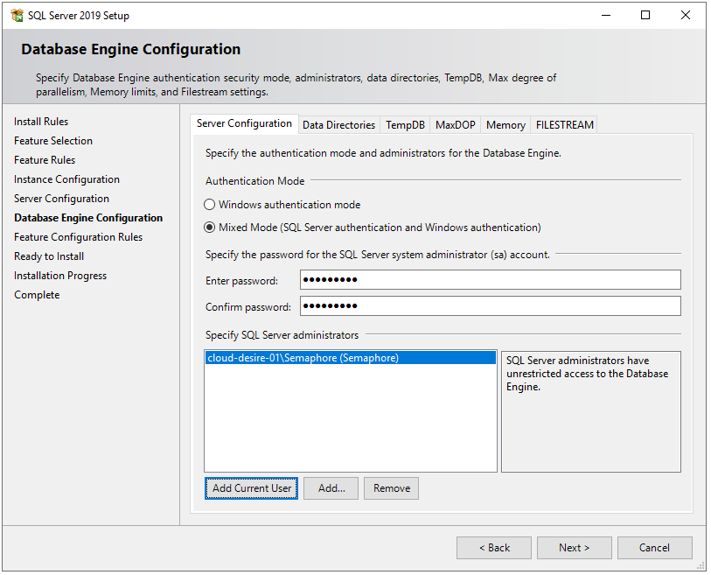

In the **Data Directories** tab, specify locations for database files and backup files. By default, it saves all the files on a C drive but it is not recommended to store database files on an OS drive because if any OS-related issue occurs then we may lose our data. Therefore, I choose D drive on my local machine.

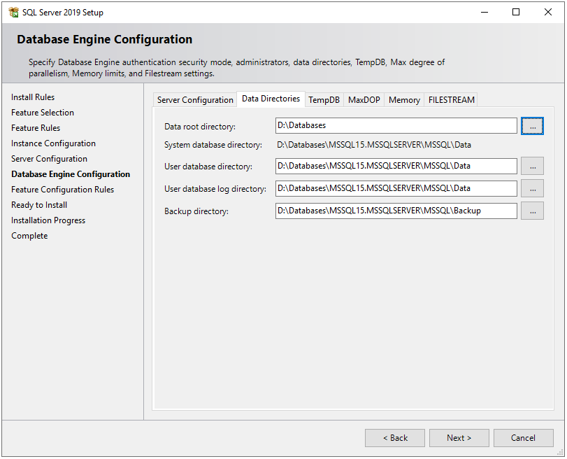

In the **TempDB** tab, there are configurations for the temporary database file(s). There are some best practices on how to configure temporary database files locations, the number of files, and their file sizes. Ideally, the number of the TempDB data files should match the number of logical processors. So I have a number of files to 2. If you are interested in deep dive into TempDB best practices, [here](https://www.sqlshack.com/how-to-detect-and-prevent-unexpected-growth-of-the-tempdb-database/) is a very good article on it.

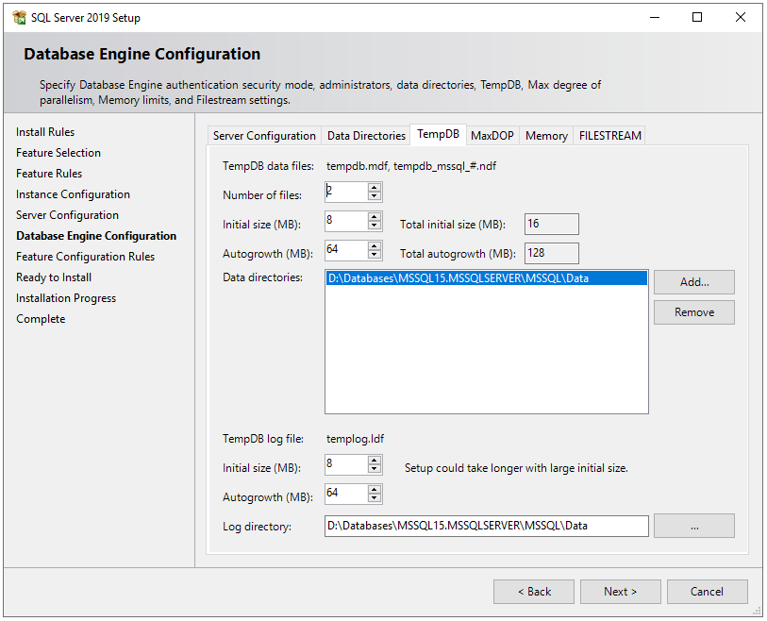

Next, in the **MaxDOP** tab, the maximum degree of parallelism (MAXDOP) is a server configuration option for running SQL Server on multiple CPUs. It controls the number of processors used to run a single statement in parallel plan execution. By default, the setup will suggest value based on the system configuration. For more information and best practices see [here](https://docs.microsoft.com/en-us/sql/database-engine/configure-windows/configure-the-max-degree-of-parallelism-server-configuration-option?view=sql-server-ver15).

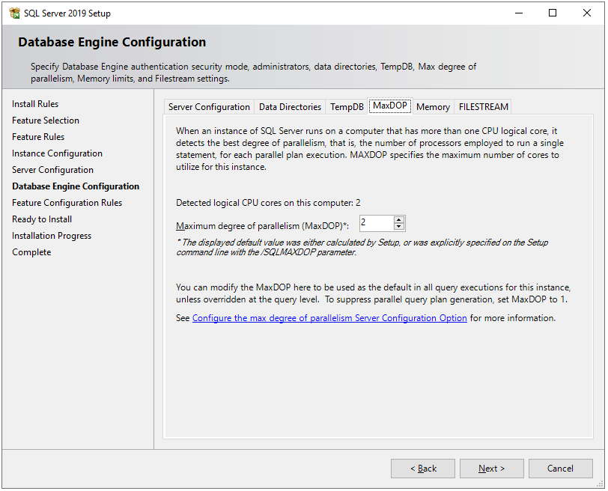

Next, in the **Memory** tab, we can configure how much memory SQL Server instance can consume. By default, the installation process will recommend you min and max memory allocation based on the system configuration on which it is going install. However, you can change it. [Here](https://codingsight.com/understanding-the-importance-of-memory-setting-in-sql-server/) you can find best practices for SQL Server memory configurations.

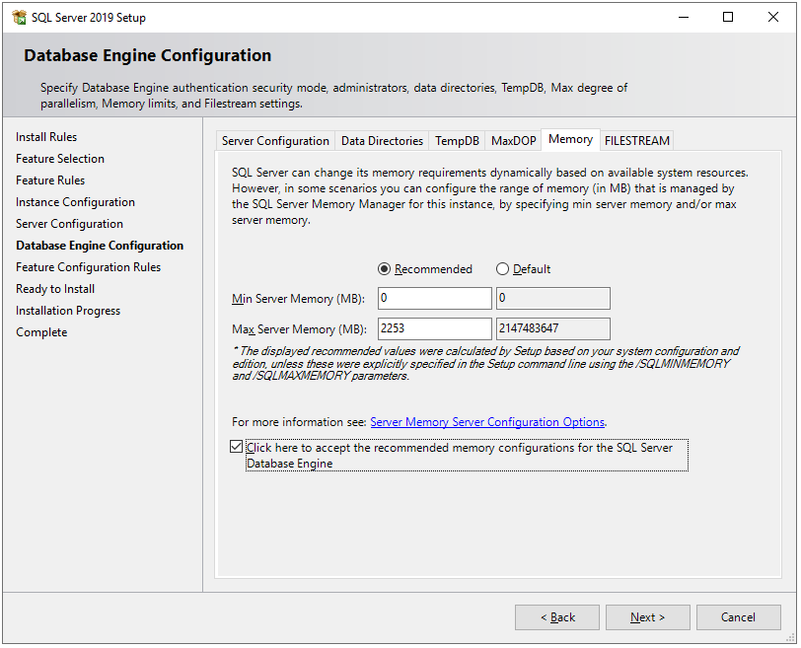

In the **FILESTREAM** tab, leave the checkbox unchecked because we are not going to enable this feature. FILESTREAM, in SQL Server, allows storing these large documents, images, or files onto the file system itself. For more information, see [here](https://www.sqlshack.com/filestream-in-sql-server/).

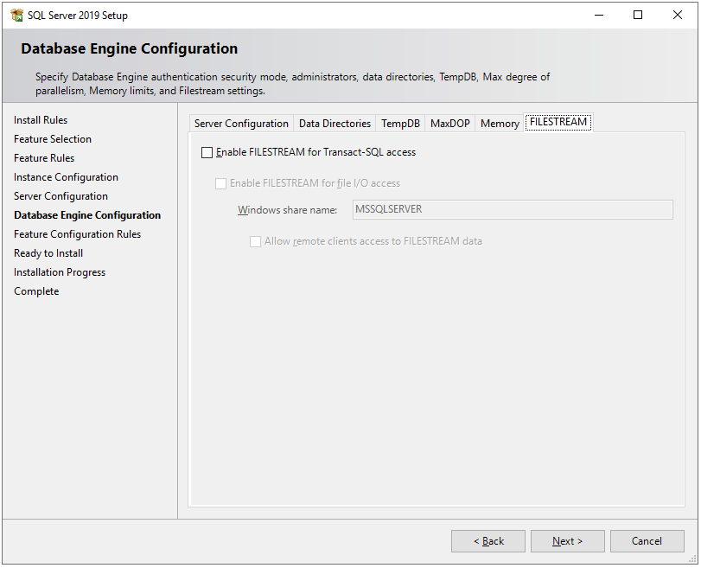

Click on the **Next** button.

**Step 12**

Next, the setup will check some feature configuration rules, and then the **Ready to Install** window will appear. This window shows the summary of all the features and configurations which we have done in the above steps. Once review the summary and click on the **Install** button.

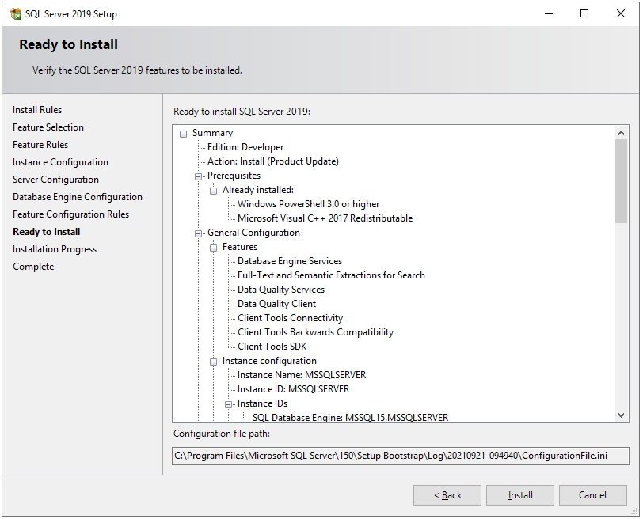

**Step 13**

Now, the installation will start and it may take some time based on our configurations.

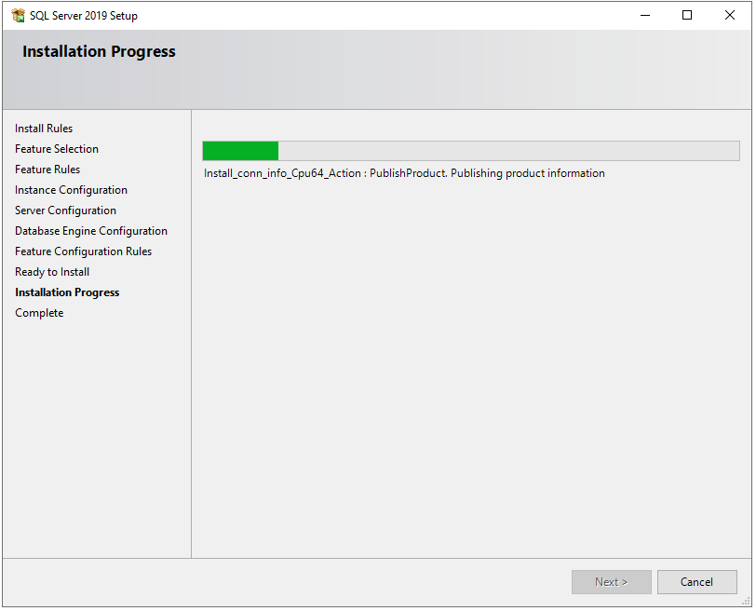

**Step 14**

After installation, it will show you the list of features and their installation status. If any error occurred, it will show here.

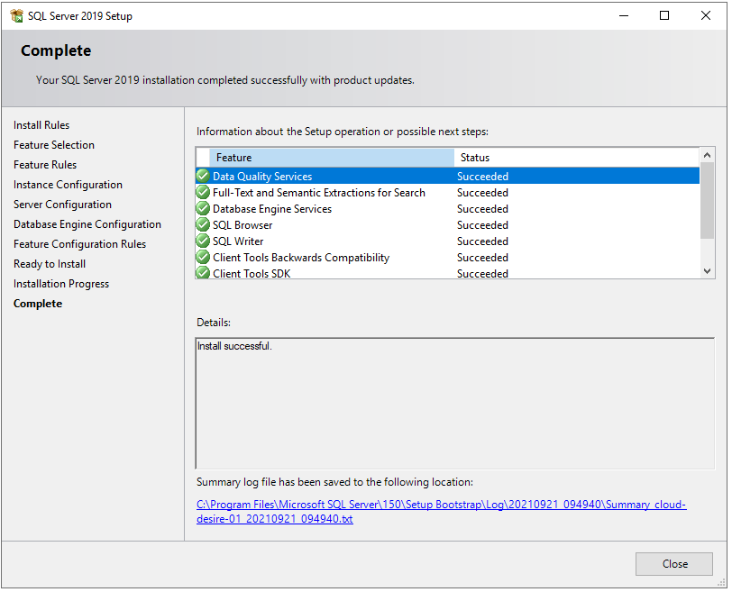

Congratulations! We have successfully installed SQL Server 2019 Developer edition on Windows machine. Next, you can install SQL Server Management Studio to connect SQL Server and query SQL databases. Please follow below steps to install SQL Server Management Studio.

## **Install SQL Server Management Studio**

First, let us download SQL Server installation media from the official website.

**Step 1**

Download installation media from these [link](https://docs.microsoft.com/en-us/sql/ssms/download-sql-server-management-studio-ssms).

**Step 2**

Below file will download.



**Step 3**

Run the downloaded file and you will see below screen. Just click on the **Install**button.

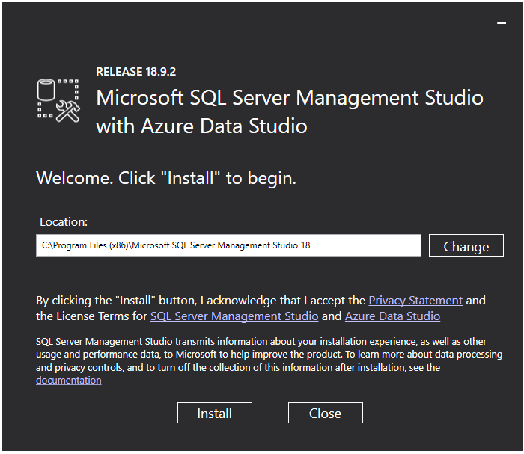

**Step 4**

It will start installing management studio. It will take some time.

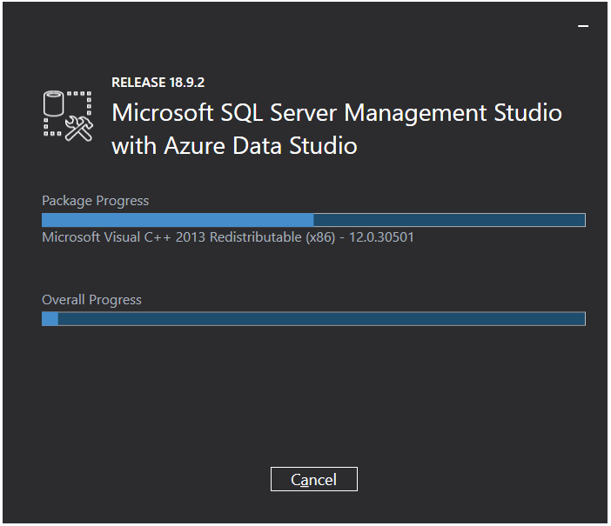

**Step 5**

Once installation finished, close the installation wizard and open start menu and search for **SQL Server Management Studio**. You will see below application. Now, click on it to open the application.



**Step 6**

Next, you will see below screen. In **Connect to Server** window, you can see the SQL instance name, which we have just installed. (Ref. Step 9). You can connect an instance with either **Windows Authentication** or **SQL Authentication**, which we have created in Step 11.

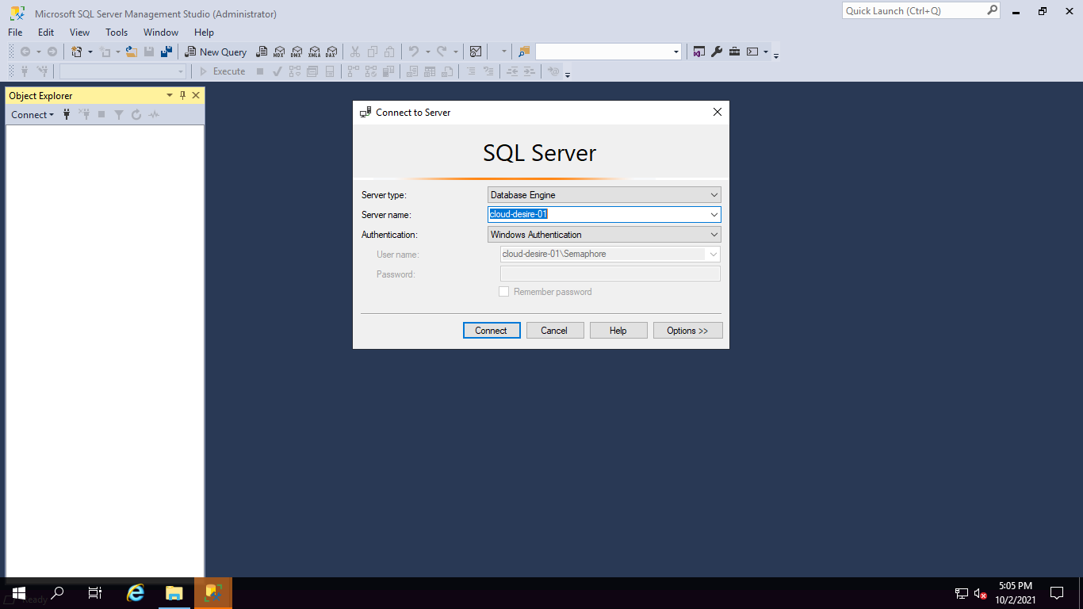

**Step 7**

Once you successfully authenticated, you can see **Object Explorer** in which you can find database list and other SQL objects.

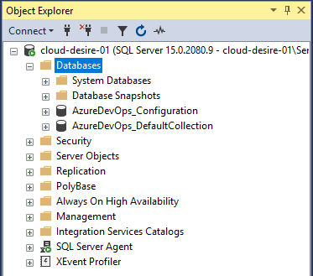

                So, hope you understand how to install and connect SQL Server using SQL Server Management Studio.

## **Expected errors/issues**

Sometimes you can face some issues/errors at the time of installation of SQL Server. Below are some known errors:

* .NET Framework 3.5 is missing - <https://www.mssqltips.com/sqlservertip/6615/error-installing-microsoft-net-framework-3-5-sql-server/>
* An error occurred for a dependency of the feature - <https://techcommunity.microsoft.com/t5/sql-server-support/sql-server-2019-installation-error-an-error-occurred-for-a/ba-p/998033>

## **Next Step**

Configure Named Pipe and TCP/IP Settings to access SQL Server Database Instance from outside or from other computers in the local network. Please check my article for [here](https://www.c-sharpcorner.com/article/configure-named-pipe-and-tcpip-settings-of-sql-server/).

**8. SYSTEM STUDY AND TESTING**

**8.1 Feasibility Study**

The feasibility of the project is analysed in this phase and business proposal is put forth with a very general plan for the project and some cost estimates. During system analysis the feasibility study of the proposed system is to be carried out. This is to ensure that the proposed system is not a burden to the company. For feasibility analysis, some understanding of the major requirements for the system is essential.

Three key considerations involved in the feasibility analysis are

* Economical feasibility
* Technical feasibility
* Social feasibility

**Economical Feasibility**

This study is carried out to check the economic impact that the system will have on the organization. The amount of fund that the company can pour into the research and development of the system is limited. The expenditures must be justified. Thus the developed system as well within the budget and this was achieved because most of the technologies used are freely available. Only the customized products had to be purchased.

### **Technical Feasibility**

This study is carried out to check the technical feasibility, that is, the technical requirements of the system. Any system developed must not have a high demand on the available technical resources. This will lead to high demands on the available technical resources. This will lead to high demands being placed on the client. The developed system must have a modest requirement, as only minimal or null changes are required for implementing this system.

**Social Feasibility**

The aspect of study is to check the level of acceptance of the system by the user. This includes the process of training the user to use the system efficiently. The user must not feel threatened by the system, instead must accept it as a necessity. The level of acceptance by the users solely depends on the methods that are employed to educate the user about the system and to make him familiar with it. His level of confidence must be raised so that he is also able to make some constructive criticism, which is welcomed, as he is the final user of the system.

### **System Testing**

The purpose of testing is to discover errors. Testing is the process of trying to discover every conceivable fault or weakness in a work product. It provides a way to check the functionality of components, sub-assemblies, assemblies and/or a finished product It is the process of exercising software with the intent of ensuring that the

Software system meets its requirements and user expectations and does not fail in an unacceptable manner. There are various types of test. Each test type addresses a specific testing requirement.

**8.2 Types of Tests**

**8.2.1 Unit testing**

Unit testing involves the design of test cases that validate that the internal program logic is functioning properly, and that program inputs produce valid outputs. All decision branches and internal code flow should be validated. It is the testing of individual software units of the application .it is done after the completion of an individual unit before integration. This is a structural testing, that relies on knowledge of its construction and is invasive. Unit tests perform basic tests at component level and test a specific business process, application, and/or system configuration. Unit tests ensure that each unique path of a business process performs accurately to the documented specifications and contains clearly defined inputs and expected results.

**8.2.2 Integration testing**

Integration tests are designed to test integrated software components to determine if they actually run as one program. Testing is event driven and is more concerned with the basic outcome of screens or fields. Integration tests demonstrate that although the components were individually satisfaction, as shown by successfully unit testing, the combination of components is correct and consistent. Integration testing is specifically aimed at exposing the problems that arise from the combination of components.

Software integration testing is the incremental integration testing of two or more integrated software components on a single platform to produce failures caused by interface defects.

The task of the integration test is to check that components or software applications, e.g. components in a software system or – one step up – software applications at the company level – interact without error.

**Test Results:** All the test cases mentioned above passed successfully. No defects encountered.

**Acceptance Testing**

User Acceptance Testing is a critical phase of any project and requires significant participation by the end user. It also ensures that the system meets the functional requirements.

**Test Results:** All the test cases mentioned above passed successfully. No defects encountered.

**8.2.3 Functional testing**

Functional tests provide systematic demonstrations that functions tested are available as specified by the business and technical requirements, system documentation, and user manuals.

Functional testing is centered on the following items:

Valid Input : identified classes of valid input must be accepted.

Invalid Input : identified classes of invalid input must be rejected.

Functions : identified functions must be exercised.

Output : identified classes of application outputs must be exercised.

Systems/Procedures: interfacing systems or procedures must be invoked.

Organization and preparation of functional tests is focused on requirements, key functions, or special test cases. In addition, systematic coverage pertaining to identify Business process flows; data fields, predefined processes, and successive processes must be considered for testing. Before functional testing is complete, additional tests are identified and the effective value of current tests is determined.

**9.2.4 White Box Testing**

White Box Testing is a testing in which in which the software tester has knowledge of the inner workings, structure and language of the software, or at least its purpose. It is purpose. It is used to test areas that cannot be reached from a black box level.

**9.2.5 Black Box Testing**

Black Box Testing is testing the software without any knowledge of the inner workings, structure or language of the module being tested. Black box tests, as most other kinds of tests, must be written from a definitive source document, such as specification or requirements document, such as specification or requirements document. It is a testing in which the software under test is treated, as a black box .you cannot “see” into it. The test provides inputs and responds to outputs without considering how the software works.

**Test objectives**

* All field entries must work properly.
* Pages must be activated from the identified link.
* The entry screen, messages and responses must not be delayed.

**Features to be tested**

* Verify that the entries are of the correct format
* No duplicate entries should be allowed
* All links should take the user to the correct page.

**CONCLUSION**

In conclusion, a well-implemented and well-utilized learning management system can revolutionize the way education is delivered and accessed. By leveraging the capabilities of an LMS, educational institutions, businesses, and individuals can enhance learning outcomes, improve efficiency, and adapt to the evolving needs of learners in the digital age.

**FUTURE ENHANCEMENT**

In the future, learning management systems (LMS) have the potential to undergo several enhancements and advancements to further improve the learning experience. Here are some possible future enhancements for LMS:

Artificial Intelligence (AI) Integration: AI can play a significant role in the LMS by personalizing learning paths based on individual learner's needs, preferences, and performance. AI algorithms can analyze data to provide adaptive learning recommendations, automated feedback, and intelligent tutoring.

Gamification Elements: Adding gamification elements such as badges, leaderboards, and rewards can enhance learner engagement and motivation. Gamified LMS interfaces can make the learning experience more interactive, enjoyable, and competitive.

Virtual Reality (VR) and Augmented Reality (AR): Incorporating VR and AR technologies into LMS can create immersive and interactive learning experiences. Learners can explore virtual environments, conduct simulated experiments, and engage in realistic scenarios that enhance understanding and retention of knowledge.

Mobile Learning: Mobile devices are becoming increasingly prevalent, and LMS should be optimized for seamless access and usability on smartphones and tablets. Mobile learning apps can enable learners to access course materials, participate in discussions, and complete assignments on the go.

Social Learning and Collaboration: Future LMS can emphasize social learning by integrating features like social media-like interfaces, discussion boards, and group projects. Collaborative tools can facilitate peer-to-peer learning, knowledge sharing, and teamwork.

Data Analytics and Learning Analytics: Advanced data analytics and learning analytics can provide valuable insights into learner behavior, performance patterns, and areas for improvement. LMS can leverage this data to personalize learning experiences, identify at-risk learners, and optimize course design.

Microlearning and Bite-sized Content: Short, bite-sized learning modules can be incorporated into LMS, allowing learners to consume content in small, easily digestible portions. Microlearning can improve knowledge retention and accommodate learners' busy schedules.

Personal Learning Assistants: LMS can integrate virtual personal learning assistants that provide on-demand support, answer queries, and guide learners through their learning journey. These assistants can use natural language processing and AI technologies to provide personalized assistance.

Blockchain Integration: Blockchain technology can enhance the security, authenticity, and verifiability of certifications and credentials issued through the LMS. By leveraging blockchain, LMS can create immutable records of achievements and enhance the credibility of learner achievements.

Multilingual Support and Accessibility: Future LMS should strive to support multiple languages and provide accessibility features for learners with disabilities. This inclusivity ensures that learners from diverse backgrounds can access and benefit from the learning materials.

These enhancements have the potential to transform the learning experience and make LMS more adaptable, engaging, and effective in meeting the needs of learners in the future.

**11.REFERANCES**

[1] Wen-xin, Li, and G. U. O. Wei. "Peking University Oneline Judge and Its Applications [J]." Journal of Changchun Post and Telecommunication Institute S 2 (2005).

[2] Kurnia, Andy, Andrew Lim, and Brenda Cheang. "Online judge." Computers & Education 36.4 (2001): 299-315.

[3] Cheang, Brenda, et al. "On automated grading of programming assignments in an academic institution." Computers & Education 41.2 (2003): 121-131.

[4] Kosowski, Adrian, Michał Małafiejski, and Tomasz Noiński. "Application of an online judge & contester system in academic tuition." Advances in Web Based Learning–ICWL 2007. Springer Berlin Heidelberg, 2008. 343-354.

[5] Lee, James B., and Brent Ware. Open Source Web Development with LAMP: Using Linux, Apache, MySQL, Perl, and PHP. Addison-Wesley Professional, 2003.

[6] Griffith, Arthur. GCC: the complete reference. McGraw-Hill, Inc., 2002.

[7] Bray, Tim, et al. "Extensible markup language (XML)." World Wide Web Journal 2.4 (1997): 27-66.

[8] "Learning management systems: An overview and comparative analysis" by Katherine Li and Richard Lalancette (2015)

[9] "Evaluating learning management system success" by Abdul Rahman Ahlan et al. (2014).

[10] "A systematic review of the literature on learning management system adoption: An overview of barriers and enablers" by Sahan Bulathwela et al. (2019).